Blog post #3

Hey everyone,

I’m pretty bad at being consistent with these posts.

It’s been nearly two-weeks since we were in Phuket now. Time is really flying by here which is kind of sad because I don’t want to leave. Currently I’m on a bus riding through rural Malaysia headed to Kuala Lumpur for the weekend.

Thailand was great! We did a ton in the short time we had there and tried to see it all. The hospitality there is no joke, nearly everyone we interacted with was extremely friendly. I’ve got a bunch of pictures from the weekend so here we go:

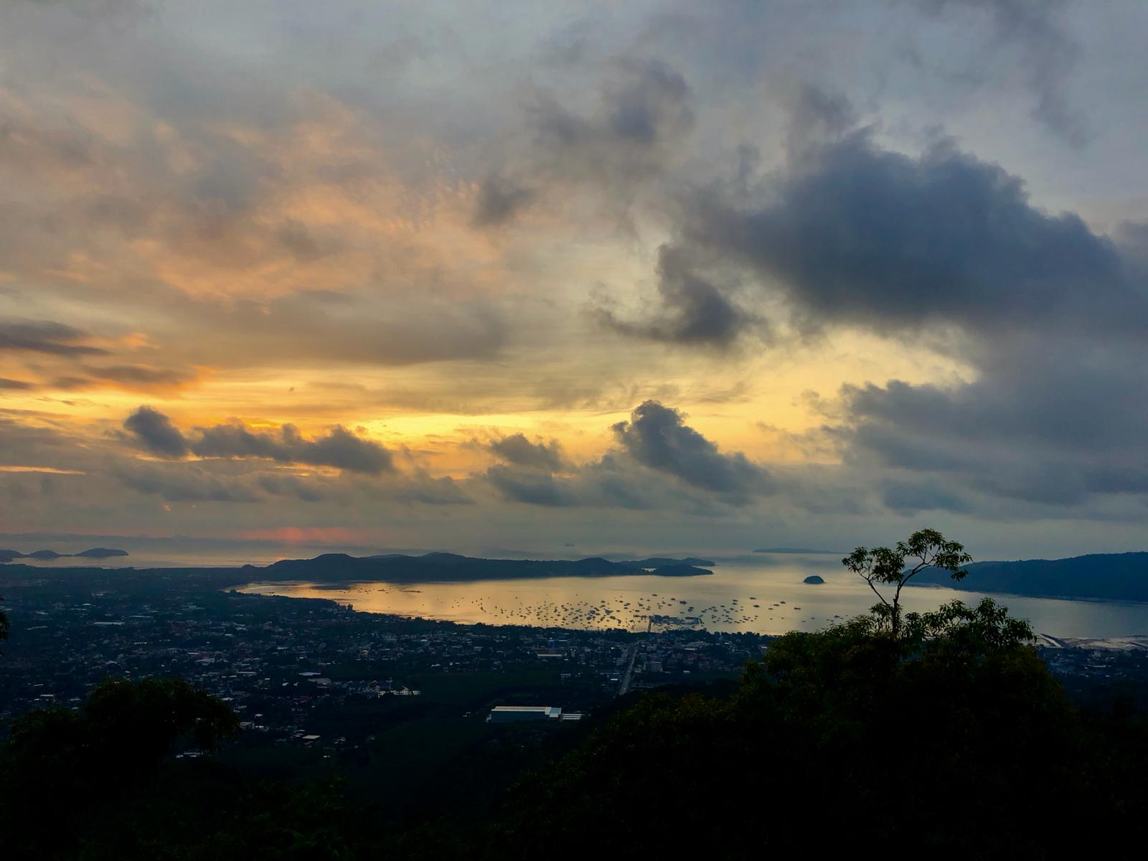

The view from Phuket’s Big Buddha. We had a tuk tuk driver pick us up bright and early so we could see the sunrise at the Big Buddha. Even with the clouds the sunrise up there was unforgettable. Also, monkeys are sketchy, rabies-filled demons.

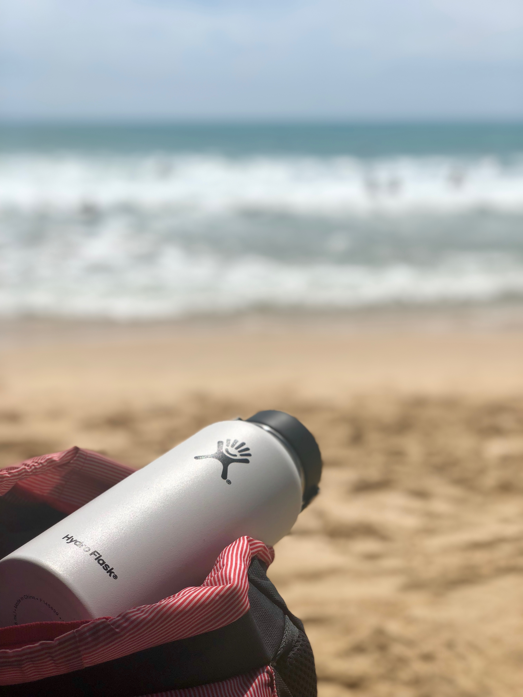

Had some fun trying to take some artsy photos by the beach. Please hire me Hydro Flask.

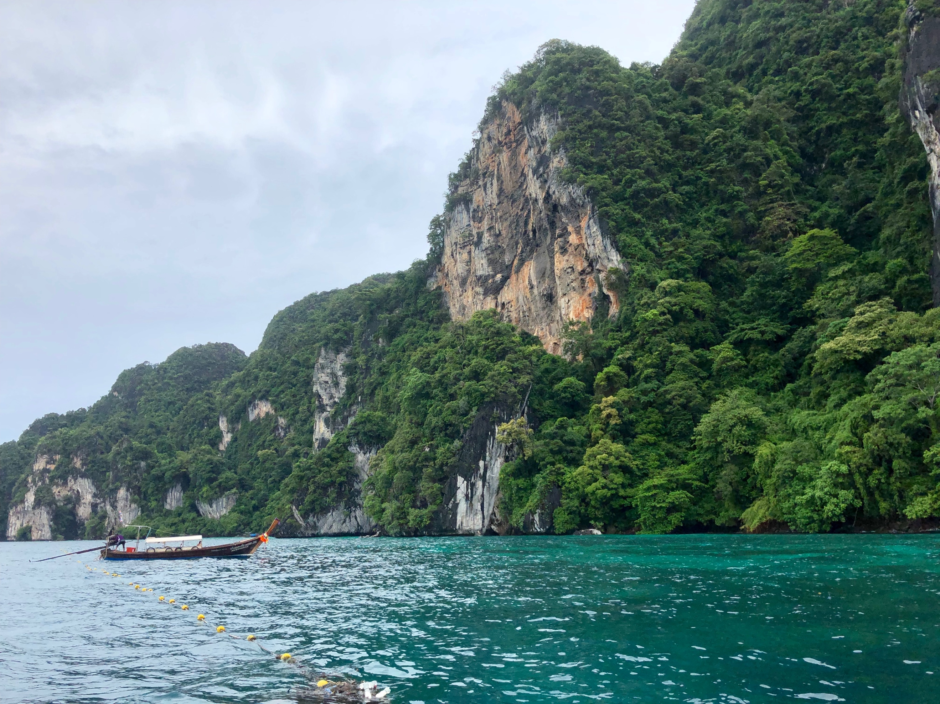

One of the highlights of the trip was boating around the Phi Phi islands snorkeling. The Phi Phi Islands are the gem of Phuket. Even though it was a bit rainy the water was warm, and it was almost nice to be cold for the first time in a while.

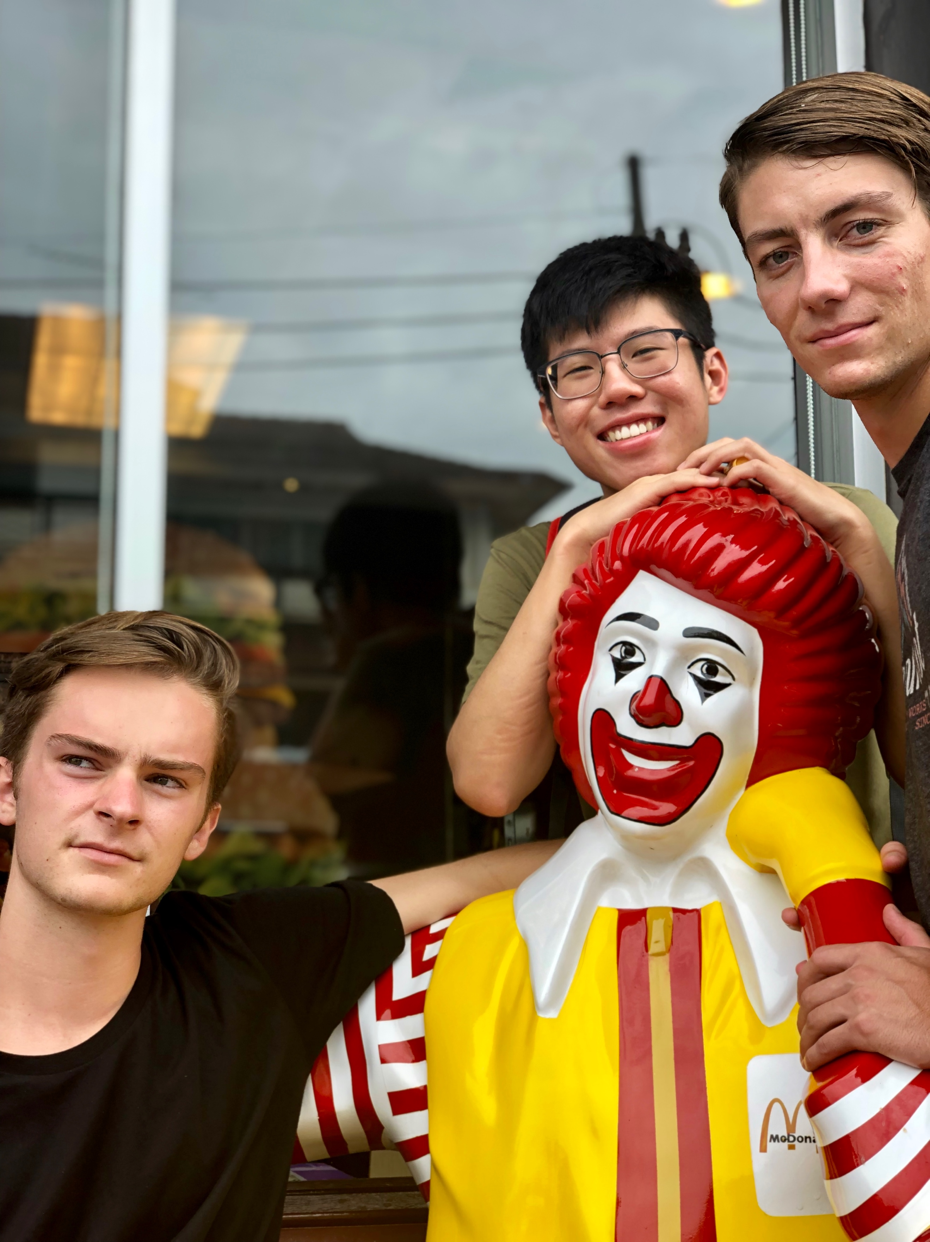

Ronald McDonald is an international icon. Now I can finally say I’ve taken a photo with a celebrity.

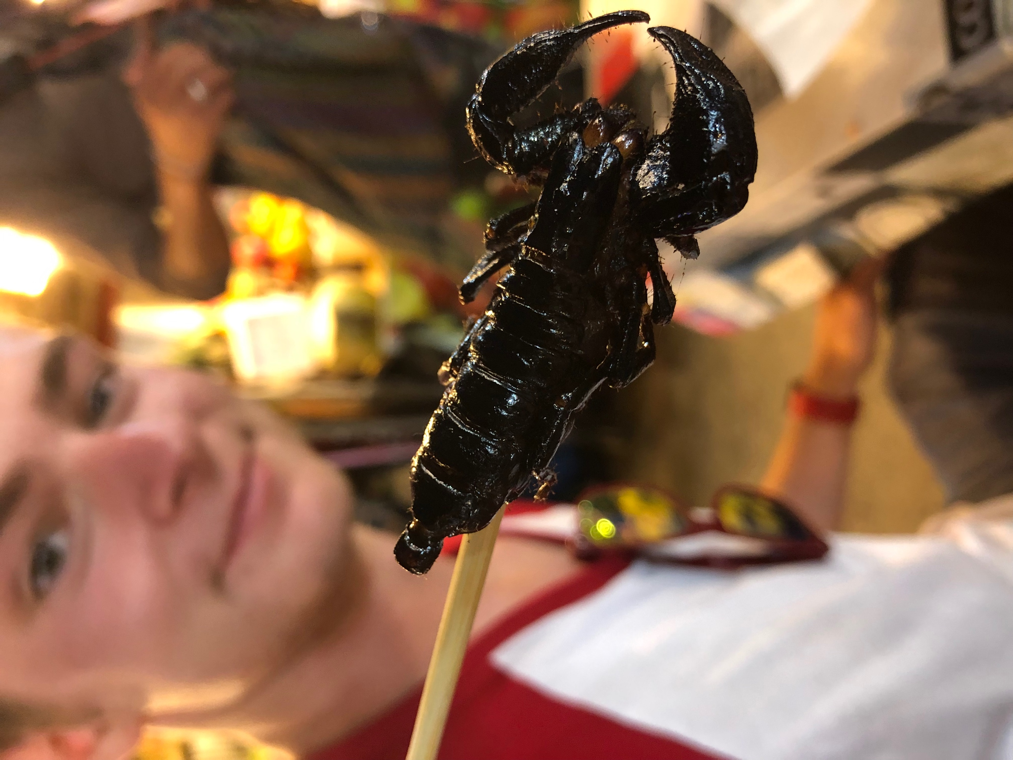

Here in Asia I’ve been discovering loads of new food groups like this bad boy. He’s a little creepy, pretty crawly, but mostly CRUNCHY. I was pretty terrified, but it was actually pretty good. With some chili sauce a scorpion could be a great after school snack.

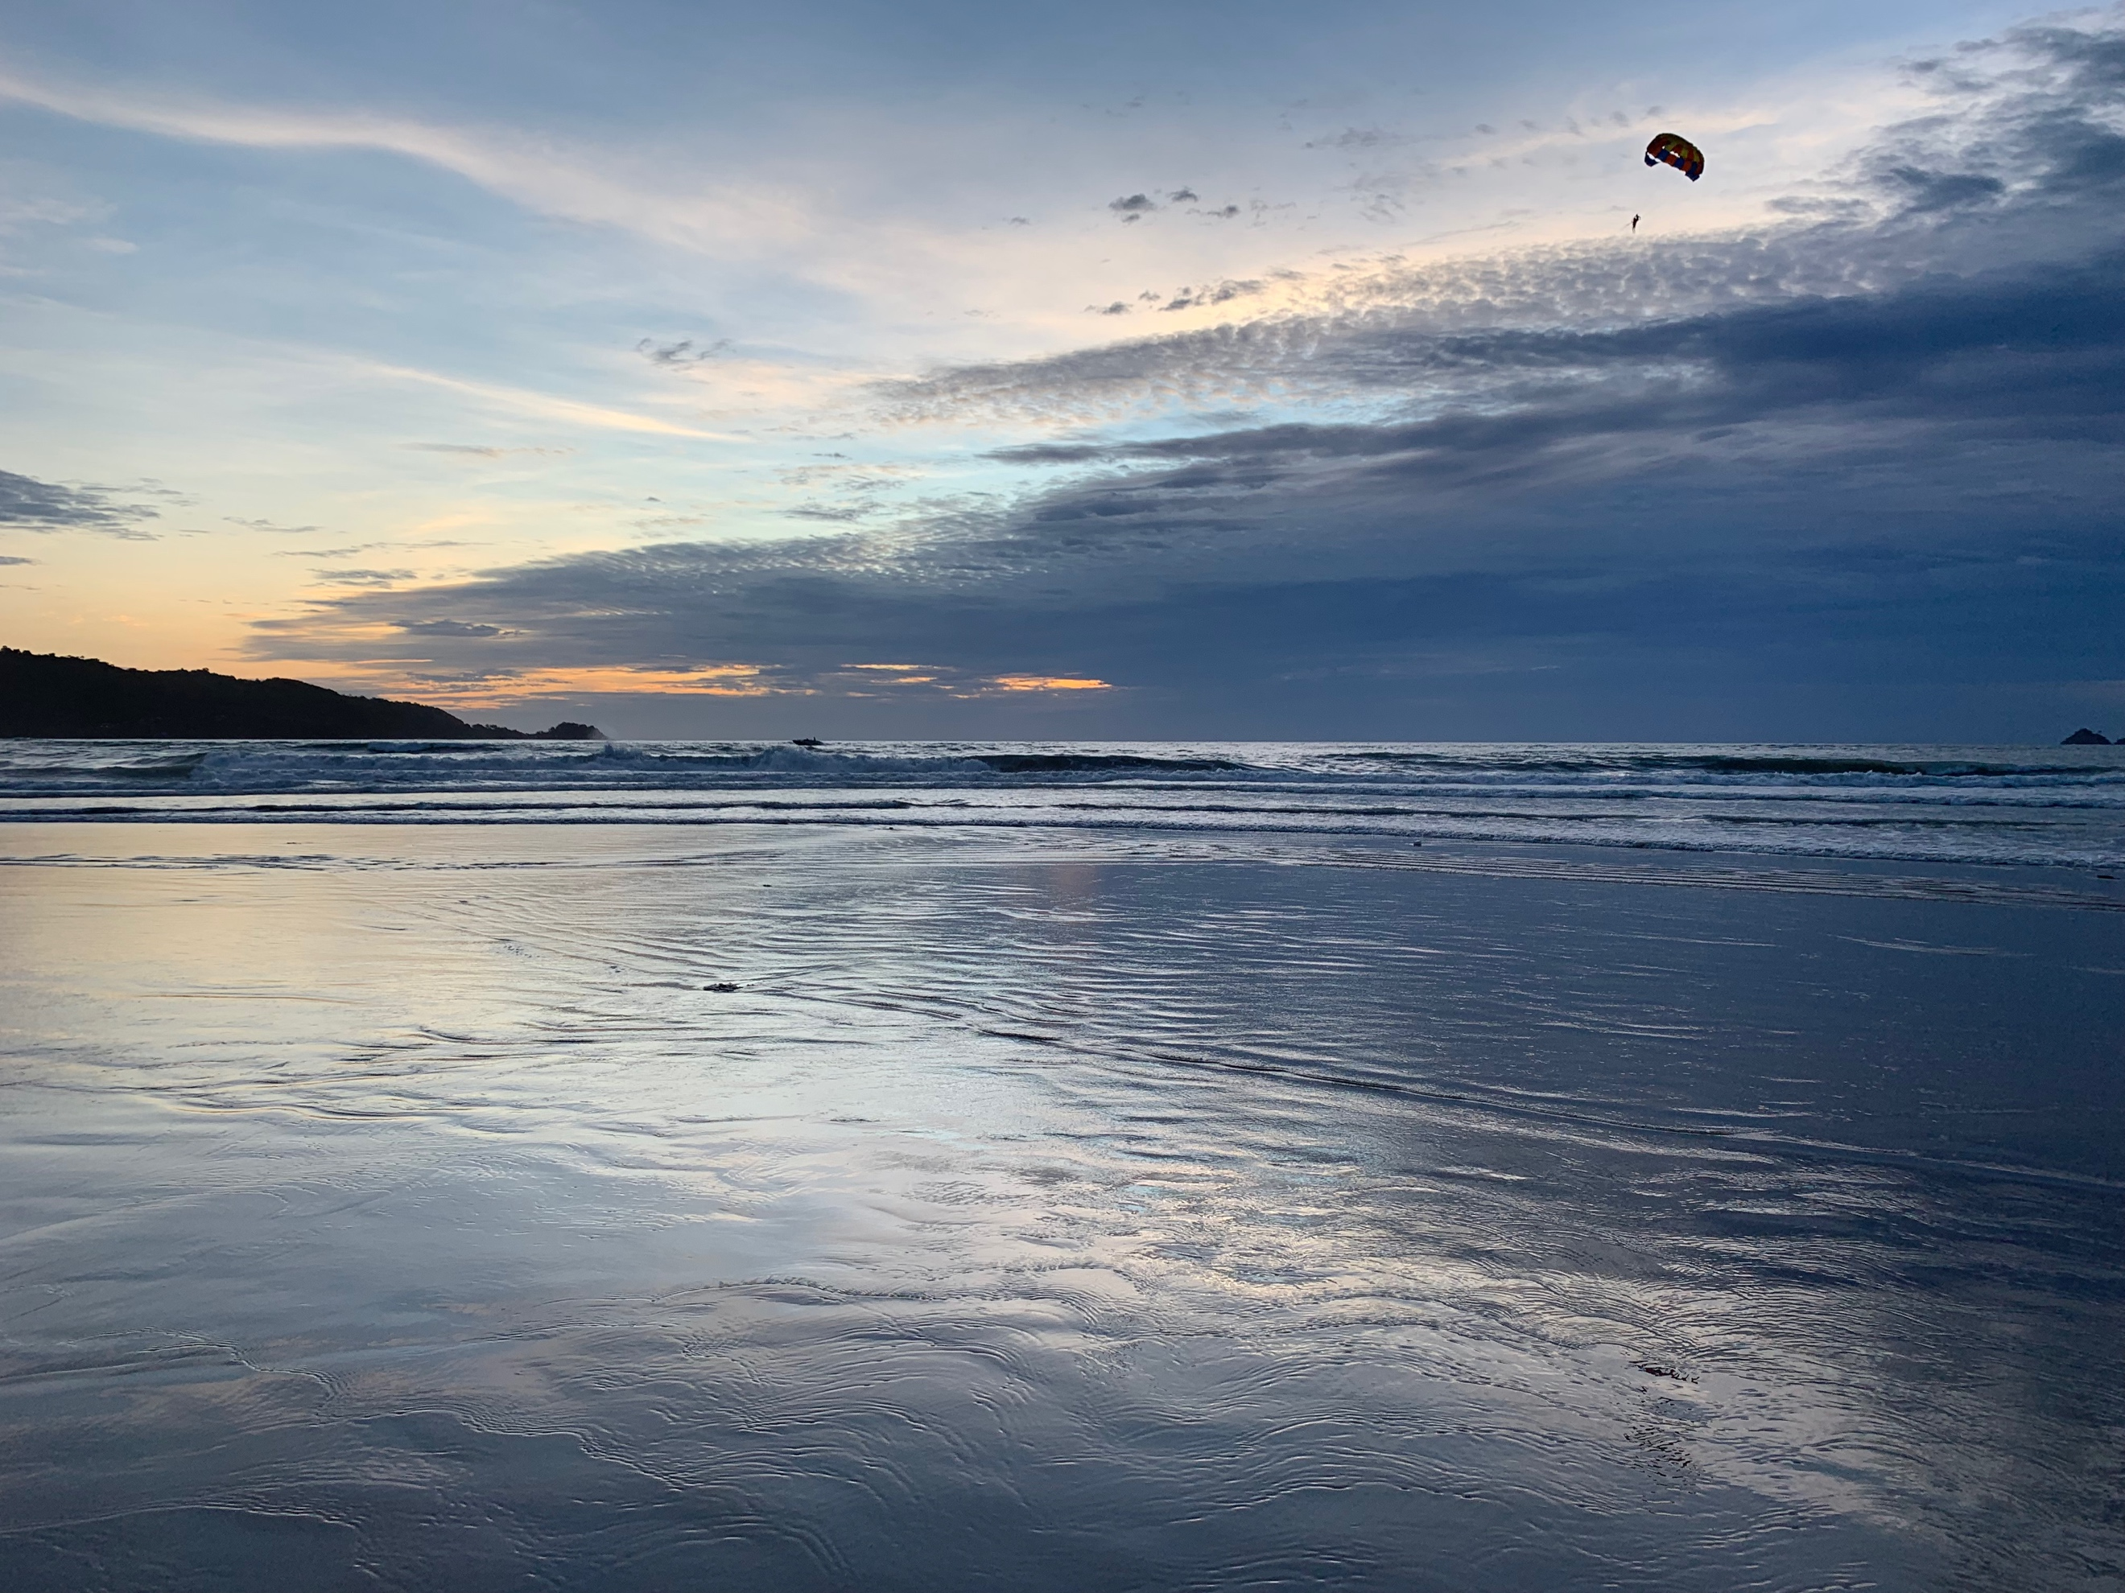

See the parachute up there? At just about any beach in Phuket you can pay to have a boat drag you around in one of these. The interesting part is, while you’re up there strapped in with a couple carabiners, there’s a guy behind you steering the whole thing who’s completely unsecured. Yikes. Makes me sweat just thinking about it. I bet it looks pretty incredible up there at sunset though.

Now I’m off to spend the weekend in a Kuala Lumpur hostel. In two weeks, we’ll have a break from class for recess week. After much deliberation, we decided on spending the whole break travelling around Myanmar. We’ll be flying into Yangon and traveling by bus to Bagan, Mandalay and Inle Lake during the week. It should be a crazy trip and I’m sure I’ll have a ton of pictures to share afterwards. Might be another blog post before then if I conjure up the courage, but I’ll end it here for now.

Thanks for reading!